In this chapter, we will discuss the system requirements for ArangoDB.

The system requirements for ArangoDB are as follows −

* A VPS Server with Ubuntu Installation
* RAM: 1 GB; CPU : 2.2 GHz

For all the commands in this tutorial, we have used an instance of Ubuntu 16.04 (xenial) of RAM 1GB with one cpu having a processing power 2.2 GHz. And all the arangosh commands in this tutorial were tested for the ArangoDB version 3.1.27.

How to Install ArangoDB?

In this section, we will see how to install ArangoDB. ArangoDB comes pre-built for many operating systems and distributions. For more details, please refer to the ArangoDB documentation. As already mentioned, for this tutorial we will use Ubuntu 16.04x64.

The first step is to download the public key for its repositories −

# wget https://www.arangodb.com/repositories/arangodb31/

xUbuntu_16.04/Release.key

Output

--2017-09-03 12:13:24-- https://www.arangodb.com/repositories/arangodb31/xUbuntu_16.04/Release.key

Resolving [**https://www.arangodb.com/**](https://www.arangodb.com/)

(www.arangodb.com)... 104.25.1 64.21, 104.25.165.21,

2400:cb00:2048:1::6819:a415, ...

Connecting to [**https://www.arangodb.com/**](https://www.arangodb.com/)

(www.arangodb.com)|104.25. 164.21|:443... connected.

HTTP request sent, awaiting response... 200 OK

Length: 3924 (3.8K) [application/pgpkeys]

Saving to: ‘Release.key’

Release.key 100%[===================>] 3.83K - .-KB/s in 0.001s

2017-09-03 12:13:25 (2.61 MB/s) - ‘Release.key’ saved [39 24/3924]

The important point is that you should see the **Release.key** saved at the end of the output.

Let us install the saved key using the following line of code −

# sudo apt-key add Release.key

Output

OK

Run the following commands to add the apt repository and update the index −

# sudo apt-add-repository 'deb

https://www.arangodb.com/repositories/arangodb31/xUbuntu_16.04/ /'

# sudo apt-get update

As a final step, we can install ArangoDB −

# sudo apt-get install arangodb3

Output

Reading package lists... Done

Building dependency tree

Reading state information... Done

The following package was automatically installed and is no longer required:

grub-pc-bin

Use 'sudo apt autoremove' to remove it.

The following NEW packages will be installed:

arangodb3

0 upgraded, 1 newly installed, 0 to remove and 17 not upgraded.

Need to get 55.6 MB of archives.

After this operation, 343 MB of additional disk space will be used.

Press **Enter**. Now the process of installing ArangoDB will start −

Get:1 [**https://www.arangodb.com/repositories/arangodb31/xUbuntu_16.04**](https://www.arangodb.com/)

arangodb3 3.1.27 [55.6 MB]

Fetched 55.6 MB in 59s (942 kB/s)

Preconfiguring packages ...

Selecting previously unselected package arangodb3.

(Reading database ... 54209 files and directories currently installed.)

Preparing to unpack .../arangodb3_3.1.27_amd64.deb ...

Unpacking arangodb3 (3.1.27) ...

Processing triggers for systemd (229-4ubuntu19) ...

Processing triggers for ureadahead (0.100.0-19) ...

Processing triggers for man-db (2.7.5-1) ...

Setting up arangodb3 (3.1.27) ...

Database files are up-to-date.

When the installation of ArangoDB is about to complete, the following screen appears −

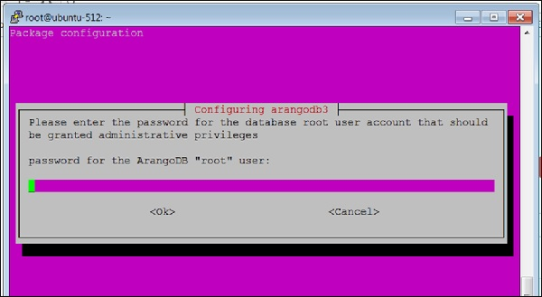

Here, you will be asked to provide a password for the ArangoDB **root** user. Note it down carefully.

Select the **yes** option when the following dialog box appears −

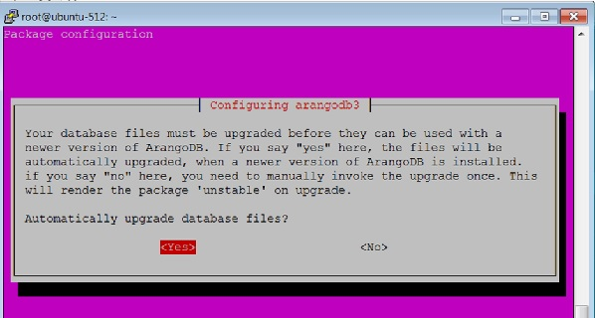

When you click **Yes** as in the above dialog box, the following dialog box appears. Click **Yes** here.

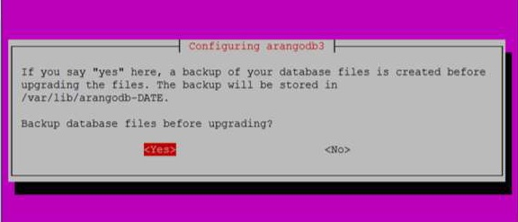

You can also check the status of ArangoDB with the following command −

# sudo systemctl status arangodb3

Output

arangodb3.service - LSB: arangodb

Loaded: loaded (/etc/init.d/arangodb3; bad; vendor pre set: enabled)

Active: active (running) since Mon 2017-09-04 05:42:35 UTC;

4min 46s ago

Docs: man:systemd-sysv-generator(8)

Process: 2642 ExecStart=/etc/init.d/arangodb3 start (code = exited,

status = 0/SUC

Tasks: 22

Memory: 158.6M

CPU: 3.117s

CGroup: /system.slice/arangodb3.service

├─2689 /usr/sbin/arangod --uid arangodb

--gid arangodb --pid-file /va

└─2690 /usr/sbin/arangod --uid arangodb

--gid arangodb --pid-file /va

Sep 04 05:42:33 ubuntu-512 systemd[1]: Starting LSB: arangodb...

Sep 04 05:42:33 ubuntu-512 arangodb3[2642]: * Starting arango database server a

Sep 04 05:42:35 ubuntu-512 arangodb3[2642]: {startup} starting up in daemon mode

Sep 04 05:42:35 ubuntu-512 arangodb3[2642]: changed working directory for child

Sep 04 05:42:35 ubuntu-512 arangodb3[2642]: ...done.

Sep 04 05:42:35 ubuntu-512 systemd[1]: StartedLSB: arang odb.

Sep 04 05:46:59 ubuntu-512 systemd[1]: Started LSB: arangodb. lines 1-19/19 (END)

ArangoDB is now ready to be used.

To invoke the arangosh terminal, type the following command in the terminal −

# arangosh

Output

Please specify a password:

Supply the **root** password created at the time of installation −

_

__ _ _ __ __ _ _ __ __ _ ___ | |

/ | '__/ _ | ’ \ / ` |/ _ / | ’

| (| | | | (| | | | | (| | () _ \ | | |

_,|| _,|| ||_, |_/|/| ||

|__/

arangosh (ArangoDB 3.1.27 [linux] 64bit, using VPack 0.1.30, ICU 54.1, V8

5.0.71.39, OpenSSL 1.0.2g 1 Mar 2016)

Copyright (c) ArangoDB GmbH

Pretty printing values.

Connected to ArangoDB 'http+tcp://127.0.0.1:8529' version: 3.1.27 [server],

database: '_system', username: 'root'

Please note that a new minor version '3.2.2' is available

Type 'tutorial' for a tutorial or 'help' to see common examples

127.0.0.1:8529@_system> exit

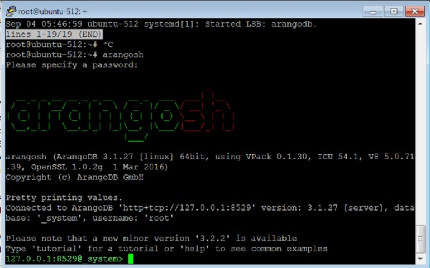

To log out from ArangoDB, type the following command −

127.0.0.1:8529@_system> exit

Output

Uf wiederluege! Na shledanou! Auf Wiedersehen! Bye Bye! Adiau! ¡Hasta luego!

Εις το επανιδείν!

להתראות ! Arrivederci! Tot ziens! Adjö! Au revoir! さようなら До свидания! Até

Breve! !خداحافظ